ROSELAND PARK
18/23 Fox Street, Hamilton East, Hamilton

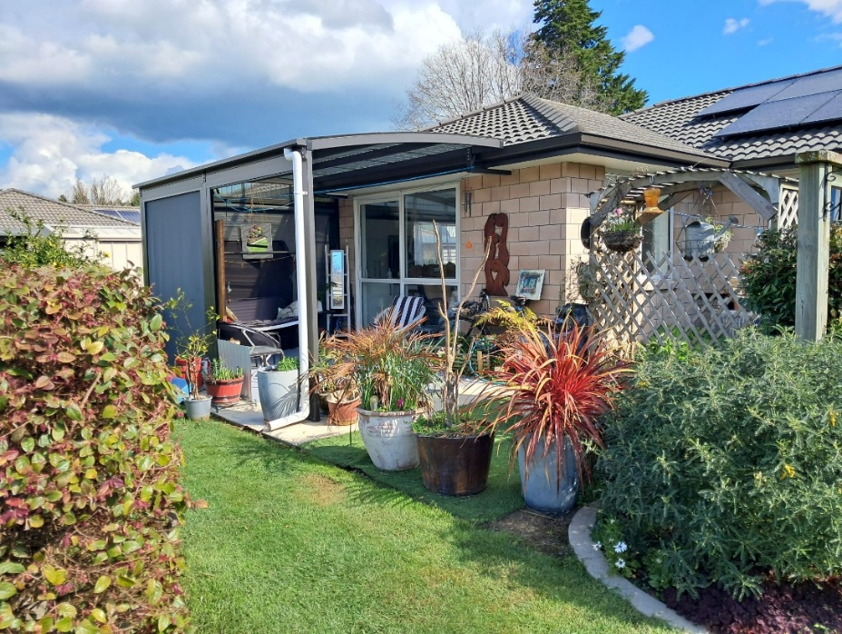
FOR SALE - UNIT 23 $785,000
There is no compromising on space here with this appealing home offering three double bedrooms, two living areas, bathroom with domed top shower and single garage with internal access.
This home boasts a generous kitchen with the expansive open plan living leading to the sunny northeast covered and curtained patio and back garden.
In winter the north sun streams in all day through the lounge window.
The modern 13 panel solar system hugely reduces power expenditure and adds long term value.
A powered garden shed is also included adding flexibility and an extra dimension to the living space.
A design that just works for easy comfortable living with plenty of storage space, large windows and a sliding door opening to the patio and back garden.
Conveniently located within the village, Unit 23 is a convenient stroll to the communal Pavilion, the hub of the village. Along with all the other benefits this village offers, you’ll get the benefit of the capital gain on your home!

Units don’t often become available, so if you are interested in viewing the village and putting your name on the Expression of interest list, please contact Graeme, the village manager, 021 449 147, manager@roselandpark.co.nz. Viewing is by appointment only.

ABOUT ROSELAND PARK VILLAGE, PART OF THE KARAKA PINES GROUP
Located a short stroll from the magical Hamilton Gardens and Waikato River, it’s also very convenient for Waikato Hospital and the new expressway. A small shopping centre for your essentials is moments away and the main Hamilton East shops and Chartwell shopping centre are just a short drive away. But having a car isn’t a necessity, because a bus stop is handy to the village, and other residents are always willing to car pool.
The village manager takes care of the day to day running of the village, along with part time Groundkeepers who look after the maintenance of the grounds and the exterior of units, helping to keep life as stress free as possible.
A favourite feature of the village among people lucky enough to live here is the Pavilion. The village has a very active social committee who arrange a variety of events ranging from communal pot-luck meals to bingo. It provides a convenient venue for socialising with other residents and can also be hired out for a small fee for larger private gatherings like birthdays and anniversaries. In addition, there is a communal vegetable garden, growing a variety of seasonal produce, available to all residents.
But of course, you can be as involved in community life in the village as much, or as little, as you like. It’s your home, so it’s entirely up to you.
As rewarding as living at Roseland Park Village can be, it doesn’t mean you’re disconnected from the wider community. The minimum age for incoming residents is 60 and many people who live in the village are closely involved with local sports and social clubs, volunteer work and some are still working.

